1. Install Kali Linux or Parrot OS

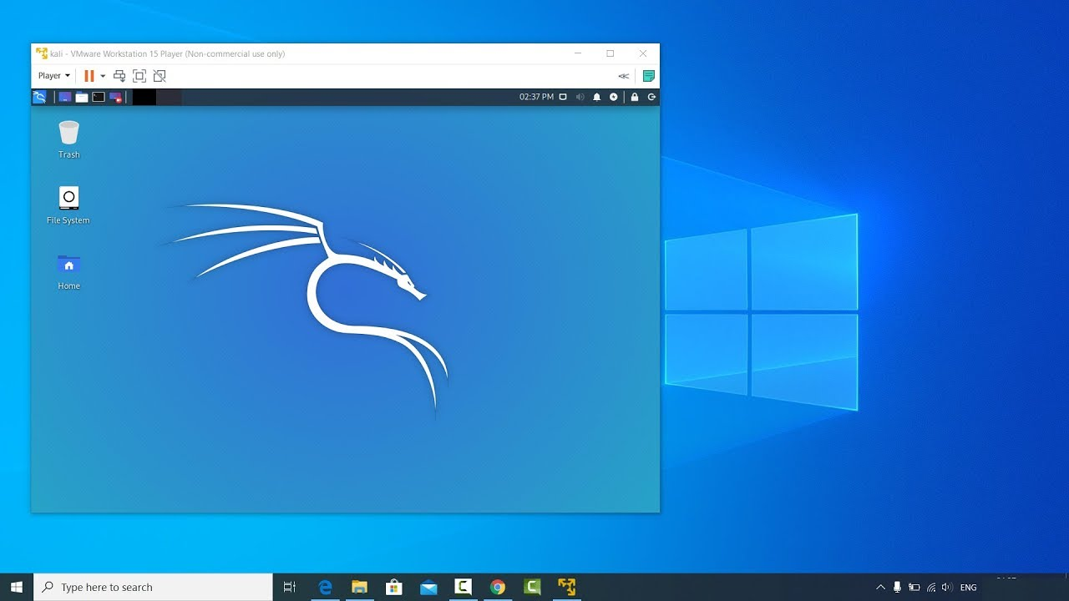

Kali Linux

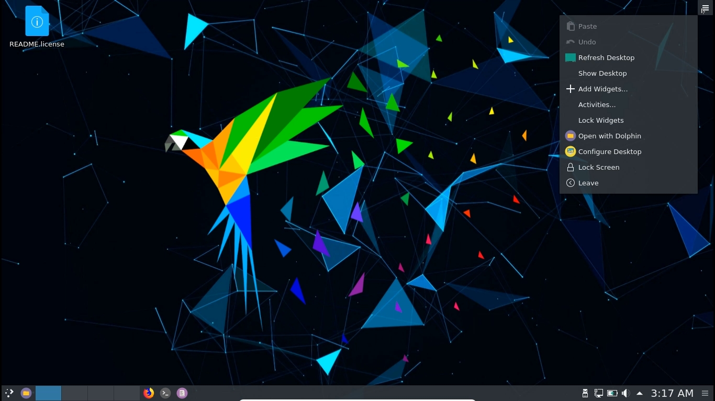

Parrot OS

1. Learn Linux commands and write them with their usage into a document and submit here.

list of Linux commands

**man**

**cd**

**ls**

**cat**

**touch**

**mkdir**

**pwd**

**echo**

**rm**

**rmdir**

**wget**

**mv**

**cp**

**tree**

**grep**

**vi**

**head**

**tail**

**wc**

**history**